KINDNES

SCHOOL NEWSLETTER (24th October 2022)

|  |
| --- |
| **KINDNESS WELLBEING INTEGRITY RESILIENCE** |

*We would like to acknowledge the Wurundjeri people of the Kulin Nation as the traditional custodians of the land on which our school stands. We pay our respects to all First Nations elders, past, present and emerging.*

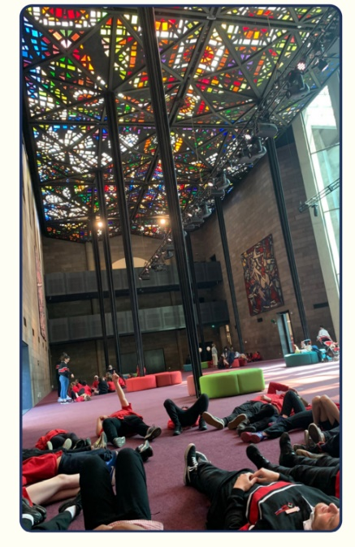

Hi Everyone,

We have had a great couple of weeks with students being involved in a variety of engaging activities! Last week, LN2 students had a wonderful time attending the National Gallery which linked to the work the students have been doing in work. Both students and staff had a wonderful time on the excurision!

Students have also enjoyed participating in the swimming program! Just a reminder that swimming is also happening this week: **Monday 24th October 2022, Tuesday 25th October 2022, Wednesday 26th October 2022** and **Thursday 27th October 2022.** A huge thank you to Mr Mac for all his hard work in organising the swimming program!

**Tribute to Aboriginal Elder**

Last week, during our assembly, Broadmeadows Valley Primary School paid our respects to Uncle Jack Charles. Uncle Jack Charles was a respected Aboriginal elder who is related to some of our Broadmeadows Valley Primary School families. He was an actor, artist, musician, mentor and advocate for promoting understanding. During the tribute, we learnt more about Uncle Jack Charles amazing work and his important role in Australia’s story.

**Pupil Free Days**

Just a reminder that both **Monday 31st October** and **Tuesday 1st November** are Pupil Free Days. Students are not required at school on both these days. We look forward to seeing all students at school on **Wednesday 2nd November**.

**World Teachers Day**

**Friday 28th October** is World Teachers’ Day. World Teachers’ Day is an opportunity to say thank you for the incredible contributions teachers make to our community.

You can get involved by sending a message of thanks to your child’s classroom teacher by sending a message via SeeSaw!

**Community Hub Celebration**

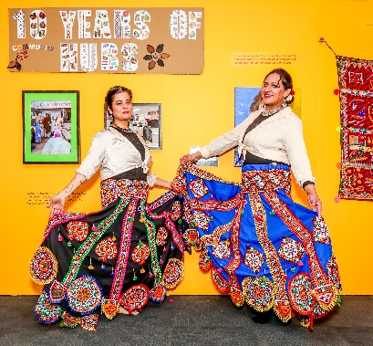On Tuesday 11th October, some of our staff and parents attended an event to celebrate 10 years of Community Hubs in Hume.

BVPS has had a Community Hub at our school since 2012. Our hub activities are open to all families and give them the opportunity to connect, share and learn together. Some of our hub activities include playgroups, adult English classes, gardening, women’s programs, training courses, excursions and additional support for families.

There is an exhibition at Hume Global Learning Centre in Craigieburn showcasing the work of our local Community Hubs network (see the attached flyer). It will be open every day until 20th November.  Visit the exhibition if you are in the area!

For more information about the exhibition, Community Hubs or any of our Broadmeadows Valley Primary School Community Hub activities, please speak to Miss Kirsten.

**Foundation 2023 Transition**

On **Wednesday, 23rd November** at 6:00pm, parents and caregivers of Foundation students 2023 will be invited to come to the school as part of an Information Session. During the session, we will be discussing in detail the Foundation 2023 Transition program. More information to be sent to families shortly.

If you know someone who lives in Broadmeadows and is interested in our school, please go to our enrolment page on the website and follow the instructions. If you already have children at our school, live in our zone and have a Foundation student for next year, please make sure you come and get the enrolment pack so we can add you to our list!!

**Broadmeadows Valley Celebration**

It’s with great pleasure to announce that on **Thursday 1st December**, Broadmeadows Valley PS will be hosting its traditional Broadmeadows Valley Celebration!! Please make a note of the date and we will send out further information shortly.

**Remembrance Day**

****Coming up on **Friday November 11th** is Remembrance Day - the day many countries around the world remember those who have sacrificed their lives for their country in war. This year it is the 104th anniversary of the end of World War I.

The poppy flower is the symbol of Remembrance Day and to support the RSL we are selling $1 pins, $2 and $5 poppies, $3 wrist bands, $4 bag tags and $5 pens at the office over the next two weeks.

If possible, please support this very worthwhile cause.

**Sun Smart**

Just are reminder that at recess and lunch times from September to April, all students must wear a hat when playing outside. Students are required to wear a school hat or another hat style that protects the face, neck and ears when outdoors, for example broad-brimmed, legionnaire or bucket.

Please ensure your child brings their hat to school each day.

***Wishing everyone a fantastic week!***

**Belinda Karlsson**

**Acting Principal**

**Learners of the Week – Week 3**

|  |  |
| --- | --- |
| **F1A** | Isa for displaying the qualities of Djinda by working hard to overcome his fears at swimming. |
| **F1B** | Ditya for displaying the qualities of Djinda. You have worked incredibly hard in our location unit. You’re always ready to share your ideas and thoughts and complete tasks to the best of your ability. Keep it up! |
| **12A** | Saniya for displaying the qualities of Rafid. You are always willing to help your classmates when they need help and can be trusted with responsibility in the classroom such as, setting up the iPads to help your teacher. |
| **12B** | Alex for displaying the qualities of Matilda. He was setting a fantastic example of road and pool safety in the swimming program, and doing his best to succeed! |
| **3/4** | Fatima for displaying the qualities of Gus and Gert by working collaboratively and respectfully with others.  Aydin for displaying the quality of Djinda by challenging himself in reading by practising every day and helping others with their reading.  Raghad for displaying the qualities of Gus and Gert by working collaboratively and respectfully with others and setting a great example for others to follow. |
| **56A** | Jharel for demonstrating the qualities of Gus & Gert. You were amazing at the Regional Basketball Finals in the way that you led your team in each game and pushed through, even when you were getting tired. Awesome work! |
| **56B** | D’ette for displaying the qualities of Djinda. You have settled into LN3 so well and have had such an incredible week. We hope you’re loving your new school and we are excited to see you grow throughout the term. |
| **56C** | Thusanth for displaying the qualities of Natia. You are always so enthusiastic during our chemical science experiments. You are a kind and inspiring learner, and it is a pleasure to teach you. |

**School Diary Dates 2022**

**Term 4 2022**

**Monday 31st October 2022-Curriculum Day (Students not required at school)**

**Tuesday 1st November 2022-Melbourne Cup Day (Students not required at school)**

**Wednesday 23rd November 2022- Foundation 2023 Information Session**

**Friday 25th November 2022-Whole School Professional Practice Day (Students not required at school)**

**Thursday 1st December 2022- Broadmeadows Valley Celebration**

**Friday 2nd December 2022-LN3 Funfields Excursion (Year 6)**

**Friday 2nd December 2022-LN2 Bounce Excursion**

**Friday 9th December 2022-Colour Run – Diversity Dash (all students)**

**Tuesday 13th December 2022- Year 6/7 Secondary School Transition**

**Monday 19th December 2022-Year 6 Graduation-Town Hall**

**Tuesday 20th December 2022-Year 6 Afterparty (at school)**

**Tuesday 20th December 2022-Last Day of School- Dismissal- 1:00pm**