KINDNES

SCHOOL NEWSLETTER (July 18th 2022)

|  |
| --- |
| **KINDNESS WELLBEING INTEGRITY RESILIENCE** |

*We would like to acknowledge the Wurundjeri people of the Kulin Nation as the traditional custodians of the land on which our school stands. We pay our respects to all First Nations elders, past, present and emerging.*

Hi Everyone,

Welcome back to Term 3 everyone! I hope you all had a relaxing break and stayed warm! It has certainly been very cold over the last few weeks. I think there might be a few more cold days to come as well!

My name is Belinda Karlsson and I’m the new Acting Principal at Broadmeadows Valley PS. I’m so excited about being your new Acting Principal and I look forward to continuing the great work at Broadmeadows Valley PS!

A big thank you to all the staff, parents and students for making me feel so welcome!

**Thank you!**

A HUGE thank you to our amazing parents, Koren Staaf, Tamara Guy and Kristen Ballerini for organising a fantastic disco on the last day of Term 2! I’ve heard amazing things about the End of Term disco by the staff and students so again a huge thank you to these amazing parents! A huge thank you also to Mr Jordan for his amazing DJ skills!

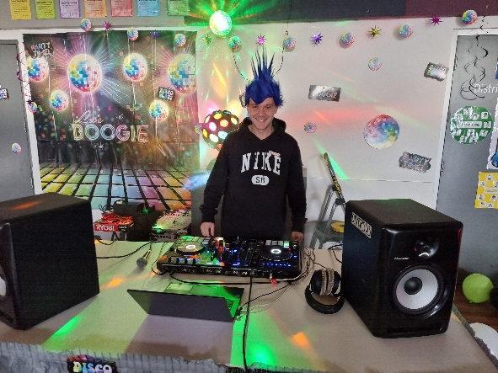

**Foundation 2023**

If you have a child who will be starting school next year, it is really important to complete the enrolment forms to ensure your child has a placement at Broadmeadows Valley PS. Our school zone: The Department’s website ‘find my school’ hosts the most up-to-date information about Victorian Government school zones. Information on this site is updated every year.

It clearly indicates the zone for each government school. You just type your address in, click primary, secondary or specialist and it will show you the zone for your local school. To visit the site, see [www.findmyschool.vic.gov.au](http://www.findmyschool.vic.gov.au)

|  |
| --- |
| **Free Rapid Antigen Tests** |

Free rapid antigen tests will be sent home with students every three weeks. Testing is strongly recommended twice a week for students and staff.

After doing the tests at home, if it is positive, you will need to:

* let the school know
* keep your child at home for 7 days
* contact the Department of Health via the COVID-19 Positive Rapid Antigen Test Self-Reporting Form or call centre on 1800 675 398.

|  |
| --- |
| **Vaccination** |

Getting vaccinated is the best way to be protected from and prevent the spread of COVID-19. I encourage all students aged 12 years and over and their parents to get vaccinated as soon as possible. To book a vaccination appointment go to coronavirus.vic.gov.au

**Learners of the Week – Week 1**

**LN3**

**5/6 Learners of the Week**

For outstanding academic achievement:**Tulia Tua**

For outstanding academic achievement: **Luca Armstrong**For being an excellent community role model: **Marli Nelson-Ioane**

**LN2**

**3/4 Learners of the Week**

For outstanding teamwork:**Rukayah Amrane**

For outstanding academic achievement: **Chase Mcaullay-Higgins**For outstanding academic achievement: **Omer Osman**

**LN1**

**Prep/1/2 Learners of the week**

For being an excellent community role model**: Judy El Kassab**For outstanding academic achievement: **Tye-Lee Charles**

For outstanding academic achievement: **Charbel Chimon**

For outstanding teamwork:**Aydin Uzun**

*Hope you have a lovely week!!!!*

**Belinda Karlsson**

**Acting Principal**