KINDNES

SCHOOL NEWSLETTER (20th March 2023)

|  |
| --- |
| **KINDNESS WELLBEING INTEGRITY RESILIENCE** |

*We would like to acknowledge the Wurundjeri people of the Kulin Nation as the traditional custodians of the land on which our school stands. We pay our respects to all First Nations elders, past, present and emerging.*

Hi Everyone,

It’s fantastic that we have nearly made it through Term 1!! A great effort by the whole school community! A reminder that the last day of Term 1 is on **Thursday 6th April at 2:30pm**. Parents/Carers are invited to attend our last day of term assembly on **Thursday 6th April at 2:00pm.** We hope to see you at the assembly!

**ANNUAL GENERAL MEETING OF BROADMEADOWS VALLEY PS:**

The Annual General Meeting is to share and discuss the 2022 Annual Report with the School Community. It’s an opportunity to share the achievements and progress of the school with the school community. This includes reflecting on the school’s performance as well as explaining the positive impact of school improvement efforts on student outcomes. All parents/carers are welcome to attend.

**Our Annual General Meeting (AGM) will take place on Tuesday 28th March 2023 at**

**4:30 pm in the LN2.**

**Harmony Day**

This month we usually celebrate Harmony Day, however we will be celebrating Harmony Day early in Term 2. Celebrating Harmony Day is important – a great way to show that we care about everyone in our community.

At Broadmeadows Valley PS, we have students from many different nations around the world so Harmony Day is a wonderful opportunity for us to celebrate and embrace our diversity.

**ANZAC DAY**[](https://www.google.com.au/url?sa=i&url=https%3A%2F%2Fwww.greenleft.org.au%2Fcontent%2Flest-we-forget-why-anzac-day-glorifies-war&psig=AOvVaw2u63tC0W26L6VaisncLDaY&ust=1583808397879000&source=images&cd=vfe&ved=0CAIQjRxqFwoTCJif8JywjOgCFQAAAAAdAAAAABAD)

Coming up in April is **ANZAC Day** one of our Nation’s most important days. ANZAC Day goes beyond the anniversary of the landing on Gallipoli in 1915. It is the day we remember all Australians who have served and died in all wars, conflicts, and peacekeeping operations.

The spirit of ANZAC, with its human qualities of courage, mate ship, and sacrifice, continues to have meaning and relevance for our sense of national identity.

ANZAC Day is on **Tuesday 25th April 2023.** (Students are not required to attend school on this day.)

**Foundation 2024**

Already, we have had enquiries about enrolments for **2024.** If you know someone who lives in Broadmeadows and is interested in our school, please ask them to telephone the school office to book a place on one of our tours. If you already have children at our school and have a Foundation student for next year, please make sure you come and collect the enrolment pack so we can add you to our list!!

**Professional Practice Day**

For Term 1, 2023, the Department of Education and Training has provided schools with the option to hold each teacher’s allocated **Professional Practice Day** on the same day for all staff. This is to enable the most effective and efficient use of this day.

As a result, we have scheduled our Professional Practice Day for **Monday 27th March 2023**. Students are NOT required to attend school on this day.

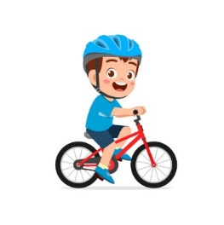

**Scooters and Bikes**

Many students at our school ride a bike or scooter to and from school and it’s important that we keep all our students safe when students are riding a bike or a scooter. Therefore, please remember that **ALL** students who ride a bike or scooter to and from school **MUST** wear a helmet.

**Egg Hunt**

The end of term is quickly approaching and to celebrate Broadmeadows Valley Primary School will be hosting a chocolate egg hunt on the last day of term on **Thursday the 6th of April.**

Students can come dressed in casual clothes and if possible, we are asking students to bring a gold coin donation to participate in the chocolate egg hunt.

All money raised will be donated to the Royal Children’s Hospital Fund. The hospital is well known for the amazing service it provides to the community.

This is a wonderful cause that we would love to support, and we are sure it will touch the hearts of many families.

Let us all help make a difference in the lives of many children.

**Sleep Health**

While we know sleep is essential for good health, research shows that many children and young people are not getting enough sleep on school nights. This can affect thinking, concentration, memory, reaction times and mood.

Research shows about 12% of primary school-aged children, a quarter of 12- to 15-year-olds and half of 16- to 17-year-olds don’t get enough sleep on school nights. The recommended amount of time to sleep for primary school-aged children is 9 to 11 hours. For teenagers, it’s 8 to 10 hours.

Signs that your child is not getting enough sleep can include:

* low mood and irritability during social interactions
* reluctance or arguing about getting off devices and going to bed
* falling asleep during the day
* difficulties waking up for school and sleeping in late on weekends to catch up.

You can help your child to improve their sleep by:

* establishing a regular sleep pattern and consistent bedtime routine
* encouraging your child to exercise and spend time outside in daylight, steering clear of vigorous activity in the hour before sleep
* encouraging them to wind down and relax before going to bed.

If your child is still having trouble sleeping, has persistent problems with low mood, excessive daytime sleepiness, restlessness in bed, severe snoring or wakening unrefreshed, despite getting adequate length sleep, they should see a doctor.

For more information on sleep health, you can refer to:

* [Why sleep is so important](https://kidshelpline.com.au/teens/issues/why-sleep-so-important#:~:text=It%20gives%20you%20energy%20to,some%2C%208%20hours%20is%20enough!), from the Kids Helpline’s
* [Sleep explained](https://www.betterhealth.vic.gov.au/health/conditionsandtreatments/sleep), from the Better Health Channel.

**Learners of the Week – Week 7**

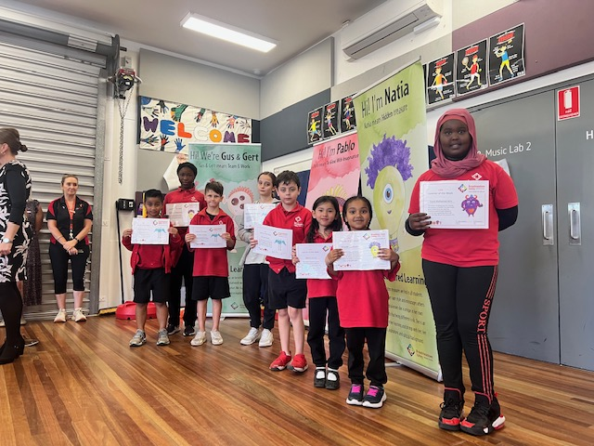

***Have a great week!***

**Belinda Karlsson**

**Principal**

**School Diary Dates- Term Dates 2023**

**Term 1**

**NAPLAN -Year 3 and Year 5 - 15th March – 28th of March**

**Science Incursion- Friday 24th March 2023**

**Professional Practice Day - Monday 27th March 2023 (no students at school this day)**

**Last Day of Term 1- Thursday 6th April 2023 (Students dismissed at 2:30pm)**

**Inter-School Sport- Term 1**

**Friday 24th March- BVPS Vs Meadows PS (Away Game)**

**Friday 31st March- BVPS Vs IIim College (Away Game)**

**Term 2**

**Curriculum Day- Monday 24th April 2023 (no students at school this day)**

**Public Holiday (ANZAC Day)- Tuesday 25th April 2023 (no students at school this day)**

**Students commence school- Wednesday 26th April 2023**

MATHS CHALLENGE

Welcome to the Week 8 Maths Challenge. Let your teacher or Miss Sharon know if you find the solution this week. Good luck and just do your best.

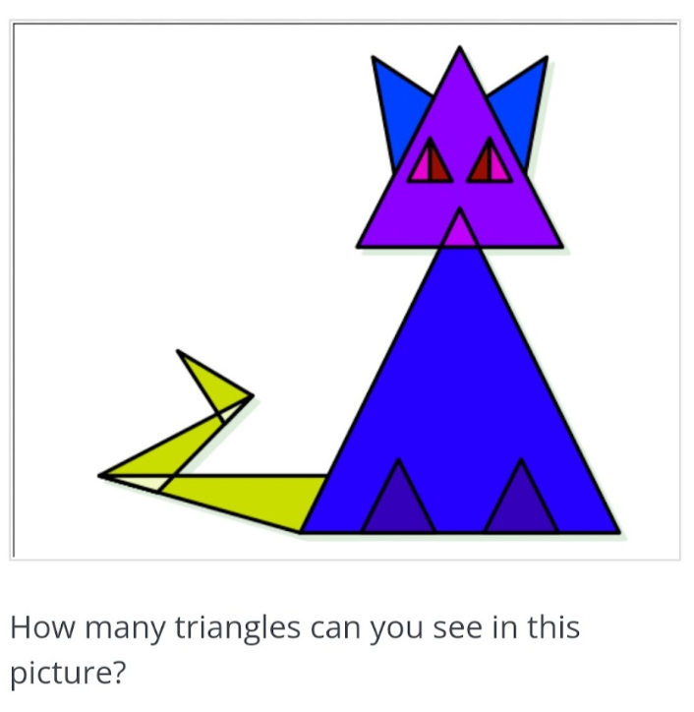

**Promoting a Positive Climate at BVPS**

**

This year we are turning our focus on increasing positive and appropriate behaviour at BVPS. Students and staff are using common language to promote and expect wanted behaviour.

Staff have been practising giving positive feedback.

Giving a positive specific two-part feedback statement helps to encourage expected behaviour as well as discourage inappropriate behaviour.

The two parts of positive specific feedback include: one part being observable behaviour, and the second part refers to the expected behaviour.

When we give feedback or a redirection statement, we need to consider how it is delivered and the follow-through.

**SOCIAL AND EMOTIONAL LEARNING**

Students have been learning about personal strengths.

Ask your child:

“What do you think your strengths are?” “How have you showed these?”

You could also tell your child the strengths you see in them.

E.g. I think you are honest, brave, kind and creative. I saw this when you helped your brother with his project.

Anxiety in Children:

## When and where to seek help

If your child regularly shows signs of anxiety, you can discuss this with their GP or another health professional, or their teacher. Some indicators that it is time to seek help include:

* if your child seems excessively worried or anxious, or feels anxious more often than not
* if anxiety stops your child from taking part in typical daily activities, such as attending school, socialising, playing or eating and sleeping well.

You can ask your GP for a referral to a psychologist. If you need help with this, ask to speak to the wellbeing team at school.

