KINDNES

SCHOOL NEWSLETTER (17th February 2023)

|  |
| --- |
| **KINDNESS WELLBEING INTEGRITY RESILIENCE** |

*We would like to acknowledge the Wurundjeri people of the Kulin Nation as the traditional custodians of the land on which our school stands. We pay our respects to all First Nations elders, past, present and emerging.*

Hi Everyone,

It is with great pleasure; I announce our School Captains and Vice- Captains for 2023!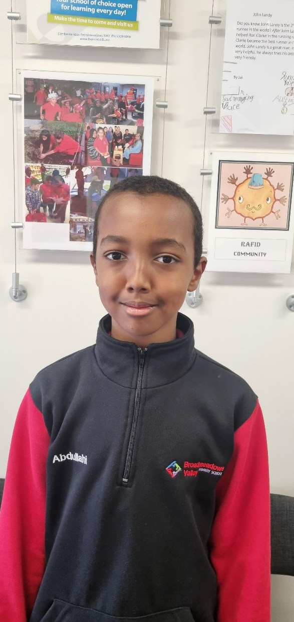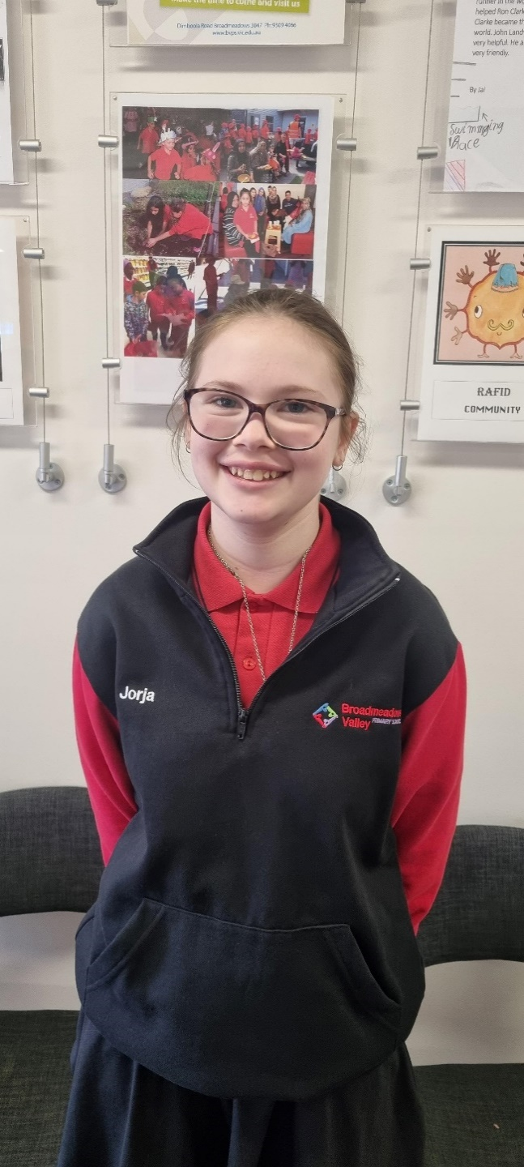

Jorga- Captain Abdullahi- Captain Austin – Vice Captain Charlie- Vice Captain

Congratulations to our School Captains and Vice Captains. I know our School Captains and Vice Captains will do an amazing job representing our school and I look forward to working with these amazing students throughout the year!

**Circle Time / Bell Times**

Just a reminder that we begin each school day with “Get ready for learning time”. By the 9:00am bell all students should be settled in their classrooms ready for learning instructions which commence at 9:00am sharp. Please ensure that your child/ren is in their classroom by 9:00am so that they do not miss crucial learning time. Every child that enters a classroom after 9:00am is not only missing important instructional time but they are potentially also causing disruption to the rest of their class.

**Communicating with Staff**

If for any reason you need to contact your child’s teacher or any other staff member, you can: please call 9386 1286 and leave a message or email broadmeadows.valley.ps@education.vic.gov.au with attention to the relevant staff member.

**Information Session**

On Thursday 9th February, we had a very successful Information Session. A huge thank you to all the parents/caregivers who attended the Information Sessions! This was a wonderful opportunity to meet those teachers who are working with your child every day at school. We hope you found the sessions useful to clarify any issues or questions you might have had!

**Foundation Tours 2024**

We will be operating Foundation 2024 School Tours on the following dates/times:

**Thursday 2nd March 2023 at 9:30am**

**Wednesday 8th March 2023 at 1:00pm**

**Wednesday 15th March 2023 at 3:30pm**

If you have a child who will be starting Foundation in 2024, please make sure you attend one of our school tours!

**Junior School Council**

This year at Broadmeadows Valley Primary School, we will be having a Junior School Council (JSC). JSC will play a positive role in creating a school environment that is caring, safe and friendly.

At Broadmeadows Valley Primary School, student leadership is a valuable opportunity for students to develop their skills in being leaders, organisers, and active members of their community. Through the many student leadership roles, students will have the opportunity to contribute to decision-making within the school and take on responsibilities for a variety of school activities.

This will give students the opportunity to lead an important program throughout our school whilst practicing their leadership skills.

A huge congratulations to Year 6 student Alizey, who is our Junior School Council Leader!

Please keep an eye out each fortnight in the newsletter regarding events which will be lead by our JSC!

**Annual Privacy Reminder for Our School Community**

Our school collects, uses, discloses and stores student and parent personal information for standard school functions or where permitted by law, as stated in the Schools’ Privacy Policy. Please take time to read our school’s collection notice, visit our privacy policy by [clicking here](https://www.bvps.vic.edu.au/page/266).

We ask parents to also review the guidance we provide on how we use Google Workspace for Education safely at the school and what parents can do to further protect their child’s information. If after reviewing the guidance, you have any questions or concerns regarding your child using [Google Workspace](https://arc.educationapps.vic.gov.au/software/26/details) for Education, please contact the school.

**Meet Our New Staff- Yulia Rachmawati**

My name is Ms. Yulia and I feel so privileged to take the role as the Performing Arts teacher at BVPS. I attended my teaching course at Deakin University specialising in both early childhood and primary teaching. Most of my education experience is in Melbourne but last year I moved to Canberra to take a position as a primary school teacher. Prior to that, I have worked in the early childhood education sector for more than ten years. My teaching philosophy is that I believe that students are capable learners and can express this at any age, and my job is to inspire and empower them to think and work like artists.

**Art Club**

Broadmeadows Valley Primary School started the year by having our fantastic, creative Art club. Every Friday at snack time students will be able to attend Art Club and participate in a variety of creative and calming activities such as drawing with stencils and chalk. We would like to invite all BVPS students to Art Club every Friday to explore their creative side.

**Sun Smart**

Just a reminder that at recess and lunch times from September to April, all students must wear a hat when playing outside. Students are required to wear a school hat or another hat style that protects the face, neck and ears when outdoors, for example broad-brimmed, legionnaire or bucket.

Please ensure your child brings their hat to school each day.

**CSEF**

Just a reminder CSEF applications are currently open for 2023 and are due back by **24th February 2023.** For more information about CSEF applications, please speak to our Admin staff.

**Learners of the Week – Week 3**

***Have a great weekend!***

**Belinda Karlsson**

**Principal**

**School Diary Dates**

**Term Dates 2023**

**Term 1**

**School Council Meeting- Tuesday 21st February 2023**

**Foundation 2024 School Tour- Thursday 2nd March at 9:30am**

**Foundation 2023 School Tour - Wednesday 8th March at 1:00pm**

**Public Holiday- Monday 13th March 2022 (no students at school this day)**

**Foundation 2023 School Tour- Wednesday 15th March at 3:30pm**

**School Photos-Wednesday 3rd May 2023**

**Last Day of Term 1- Thursday 6th April 2023 (Students dismissed at 2:30pm)**

**School Council**

**Schedule 4: Notice of Election and Call for Nominations**

An election is to be conducted for members of the school council of Broadmeadows Valley Primary School.

Nomination forms may be obtained from the school and must be lodged by 4.00pm on **Friday 24th February 2023.**

Following the closing of nominations, a list of the nominations received will be posted at the school. The terms of office, membership categories and number of positions in each membership category open for election are as follows:

|  |  |  |
| --- | --- | --- |
| **Membership Category** | **Term of Office** | **Number of Positions Vacant** |
| Parent Member | From the day after the date of the declaration of the poll in 2023 and inclusive of the date of the declaration of the poll in 2025.  (2 years) | 1 |
| DET Employee Member | From the day after the date of the declaration of the poll in 2023 and inclusive of the date of the declaration of the poll in 2025.  (2 years) | No Vacancies |
| Community Member | From the day after the date of the declaration of the poll in 2023 and inclusive of the date of the declaration of the poll in 2025.  (2 years) | 2 |

If the number of nominations is less than the number of vacancies, a notice to that effect and calling for further nominations will be posted in a prominent position at the school.

If you would like more information regarding school council and its schedule and operation please contact the office on 93094066.

MATHS CHALLENGE

Welcome to our first Math Challenge. Each fortnight there will be a new puzzle to solve. Let your teacher know if you find the solution. Good luck and just do your best.

**Promoting a Positive Climate at BVPS**

|  |
| --- |
| **Positive Climate**  This year we are turning our focus on increasing positive and appropriate behaviour at BVPS. Students and staff are using common language to promote and expect wanted behaviour.  Staff and students collaborated on identifying expected behaviours which can be seen in all the settings around our school. If you would like a copy of the expected behaviour poster please come and speak to the Wellbeing Team.  Over the past few week’s classrooms have been busy establishing procedures and routines which help to create a calm and well-structured learning environment. Some of the procedures include moving around the learning space and how to use the canteen appropriately.  To help support the learning environment staff and students are using a voice volume scale. Here is an image of a pack up procedure from 5/6B and a voice volume chart from 3/4B.  We have also begun with a focus on relationship and team building with lots of games and activities to promote students connecting to their classmates and their teachers.  Here’s a picture of Mr Hucker’s class enjoying a positive primer to get them ready for learning. |

|  |
| --- |
| **Social and Emotional Learning**  At BVPS we use the Zones of regulation that develops awareness of feelings, energy and alertness levels while exploring a variety of tools and strategies for regulation, prosocial skills, self-care, and overall wellness. This curriculum provides us an easy way to think and talk about how we feel on the inside and sort these feelings into four coloured Zones. |

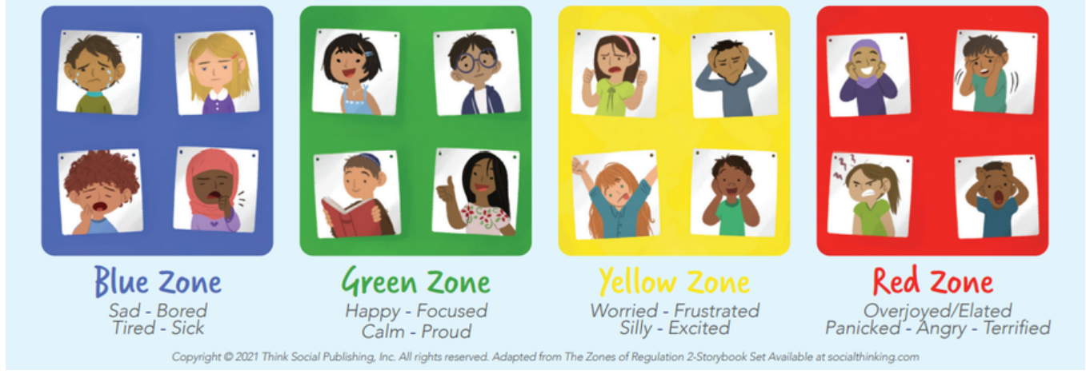

If anyone is needing support with food relief then please reach out to the services below.

Hume Food Relief Services

|  |  |  |  |  |
| --- | --- | --- | --- | --- |
| **Organisation** | **Address** | **Phone** | **Services Provided** | **Hours of Operation** |
| **Anglicare Church** | **Corner of Barry Road and Emerald Street, Broadmeadows** | **(03) 9309 2507** | **Food Parcels – $4.50 (fee can be waivered if required)** | **Friday:**  **11am – 12:30pm** |
| **Anglicare Victoria** | **Newbury Child and Community Centre, 440 Grand Boulevard, Craigieburn, VIC 3064.** | **1800 809 722** | **Woolworths Vouchers**  **Fruit and Vegetables Vouchers**  **Butchers Vouchers**  **Telstra Vouchers** | **Wednesday 9.30 am to 12:30pm and Friday**  **10:00am – 1:00pm** |

|  |
| --- |
| **Our Community**  Our classes are beginning the day with an Acknowledgement to Country to pay respect to the Traditional Custodians on the land on which we meet, learn and play each day. We also acknowledge National Apology Day held on the 13th of February 2023.  We hope to be welcoming a Community Hub leader soon. Currently running on a Wednesday morning from 9:30-11am is a gardening session that all are welcome to. There are also English Language classes held each Tuesday and Thursday at Gowrie from 1-3pm.  All our students have the opportunity to see the Teeth on Wheels dentist in the next coming weeks. Please see the office or your teacher for a referral form.  **Upcoming Events**   * International Women’s Day on Wednesday March 8th, 2023 * Harmony Week March 20 - 26th, 2023 * Wellbeing Team Pizza and Plane afternoon March 30th 3.20pm - 4.30pm |