KINDNES

SCHOOL NEWSLETTER (3rd February 2023)

|  |
| --- |
| **KINDNESS WELLBEING INTEGRITY RESILIENCE** |

*We would like to acknowledge the Wurundjeri people of the Kulin Nation as the traditional custodians of the land on which our school stands. We pay our respects to all First Nations elders, past, present and emerging.*

Welcome to 2023!

I hope everyone has had a relaxing holiday break and that you are ready to go for a busy year ahead. It’s been great to see everyone back and eager to learn!

Welcome to the new families that have joined us at Broadmeadows Valley Primary School.

**Also, a huge warm welcome to our new Foundation Students that started their school journey this week!**

**We are very happy to have the students and their families join our school community.**

**Student Enrolment**

Student enrolment information forms will be sent to all students/families next week. We are asking for families to please check all information and return the signed form to their classroom teacher by 24th February.

**School Booklist**

School booklist contribution form and payment $60 due by 24th February. Forms have been sent home this week. If you require another form, please contact the office.

**Student Attendance**

All student absences must be supported by a note from families and/or medical certificate and returned to their classroom teacher. If you need to collect your child/ren early for any reason, please present to the office. Please also ensure your child/ren arrive on time to school.

**Medication**

Medication MUST be bought up to the office by a parent/ caregiver with a signed permission form. Students are NOT allowed to have medications stored in their school bag.

**Staffing**

A special welcome back to our staff at Broadmeadows Valley Primary School. The staff are always willing to help in any way they can so please see them if you have any issues. I have listed them with their roles, so you know who they are. They all have name badges, so staff members are clearly identified.

**Class Structure 2023**

|  |  |
| --- | --- |
| **Staff** | **Role** |
| Belinda Karlsson | Principal |
| Jamielee Black | Assistant Principal |
| Sharon Goldfinch | Curriculum Leading Teacher |
| Celene Black | Wellbeing Leading Teacher |

|  |  |
| --- | --- |
| **Year Level** | **Staff** |
| F/1 | Sema Yagiz |
| F/1 | Jen Thompson |
| 1/2 | Jordan Colombo |
| 2/3 | Jason Hucker |
| 3/4 | Ryan Machell |
| 3/4 | Sarah Maroukel |
| 4/5 | Wendy Cecchini |
| 5/6 | Iesha Taha |
| 5/6 | Ash Macarthur  Laurena Magdalani |

|  |  |
| --- | --- |
| **Teacher** | **Specialist Role** |
| Ash Macarthur | Physical Education |
| Yulia Rachmawati | Performing Arts |
| Marina Lopez Garcia | Visual Arts |
| Liam O’Grady | Digital Technologies |
| TBC | Community Hub |
| Mitch Flavell | Student Counsellor |
| Nic Brady | ICT/OHS |
| Nadia McComb | MHiPS Co-ordinator |

|  |
| --- |
| **Admin** |
| Jenny Petrone (Business Manager) |
| Lindy Rider |

|  |  |
| --- | --- |
| **Education Support** | |
| Christine Tuakana | Emma Varallo |
| Rugia Ibrahim | Leanne Mustard |
| Mirna Kid | Sam Yehia |
| Kim Smith |  |

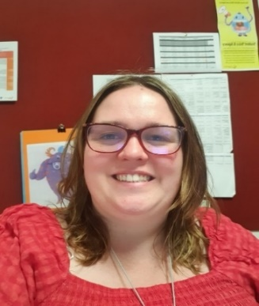**Meet Our New Staff- Nadia McComb**

Hi, my name is Nadia McComb, and I am the new Mental Health and Wellbeing Leader (MHWL) this year. The role of the MHWL is to build the capability of the whole school about mental health and wellbeing (identification, promotion and prevention), to provide support to staff to better identify and support students with mental health needs, establish clear pathways for referral for students requiring assessment and intervention, and monitor and evaluate student progress.

You may see me: undertaking lunch clubs, writing wellbeing newsletters, support students with resources in the classroom, linking families and students with different services, provide training to staff and community, attend meetings with families, bring different agencies into the school, promote a supportive school environment.

**Meet Our New Staff- Mitch Flavel**

Hello, my name is Mitch Flavel and I'm the new Student Wellbeing Counsellor at BVPS. In my role as a Counsellor, I'll be supporting the wellbeing of students in various capacities as part of the wellbeing team. I'll be working with students one on one as well as lunchtime groups and in the classroom. I love working with young people and am very excited about working more with the BVPS community.

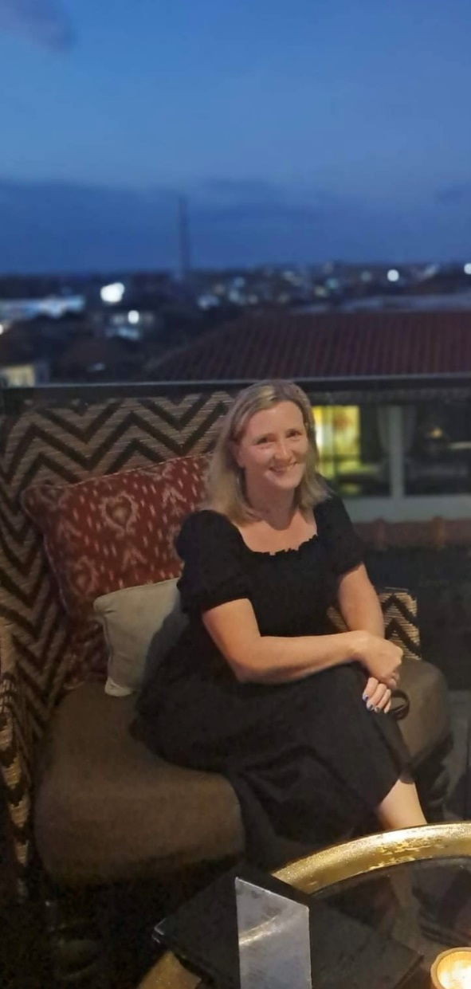Some fun facts about me include, I love Pokémon, I enjoy playing netball and I have one cat and one dog. If you see me in the yard, please feel free to say hello and have a chat.

**Meet Our New Staff- Kim Smith**

My name is Kim Smith and I work as an Education Support Staff. I provide additional support to students to support them with their learning. I love the AFL and follow North Melbourne. I like watching all sports but my favourite is tennis. Summer is my favourite time of year, so anything to do with water is usually where you will find me. Travel is a big part of my life, the number one thing to do on my bucket list is to one day visit Egypt.

**Sun Smart**

Just are reminder that at recess and lunch times from September to April, all students must wear a hat when playing outside. Students are required to wear a school hat or another hat style that protects the face, neck and ears when outdoors, for example broad-brimmed, legionnaire or bucket.

Please ensure your child brings their hat to school each day.

**CSEF**

CSEF applications are open for 2023 and are due back by 24th February 2023. Forms have been sent home during the week.

**Single Use Plastics Ban- From 1st February 2023**

Under new regulations, from 1 February 2023, Victorian businesses and organisations (including schools) will not be able to sell, supply or provide a number of single-use plastic items. The ban applies to the following single-use plastic items made from conventional, degradable or compostable plastics:

* Drinking straws
* Cutlery including knives, forks, spoons, chopsticks, sporks, food picks and sporks
* Plates
* Drink stirrers and sticks
* Cotton bud sticks

The ban also applies to:

* Food service items and drink containers made from expanded polystyrene. This includes expanded polystyrene plates, cups, bowls, clam shells and any cover or lid that is also made from expanded polystyrene.

Broadmeadows Valley Primary School will be implementing the Victorian government’s single-use plastics ban in the items we use as a school community including at the canteen, catering at fundraising events, classroom and staffroom activities and other school events.

**Teeth on Wheels**

On the 7th of March and 27th of March we will have Teeth on Wheels visiting our school for free dental checks for our students. If you wish to have your child/ren seen by Teeth on Wheels, please return the consent form to home group teachers by the 21st February 2023. If a new note is needed, please pass on the message to your child/ren’s Home Group teacher.

**Information Evening**

Families are invited to attend an information evening for each Learning Neighbourhood. At this session teachers will share information about student learning, neighbourhood expectations and important information to help you support your children during the school year.

**When: Thursday 9th of February 2023**

**Times: LN1 3:30 – 3:45pm LN2 3:50 – 4:05pm LN3 4:10 – 4:25pm**

**Where: Learning Neighbourhood Two (follow the signs)**

**There will be free sausages available on the evening.**

**Ice-cream on sale for $4 or $5**

Families in attendance will receive a free raffle ticket to enter the draw to win a $50 gift card. A raffle ticket will be given for every neighbourhood presentation you attend for your children. The prize will be drawn at the end each session.

We look forward to seeing you at the evening!

**Breakfast Club**

**Great news! Breakfast Club will start on Monday 6th February 2023 at 8:15am.**

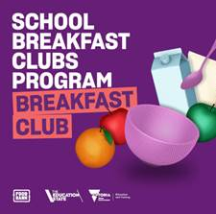Breakfast Club is open each morning this term from 8:30am - 8:45am in the gym foyer. It was wonderful to see so many students attend our first session of the year.

Breakfast Club is delivered by the Victorian Government in partnership with Foodbank Victoria, the program provides healthy meals to help students focus better and participate fully in their education.

Our School Breakfast Club aims to ensure students start the day with a healthy meal and to help students make friends and strong social connections.

Breakfast Club is free and open to everyone!

**OHS**

Please note that noodles in a cup that require hot water at school are not permitted. Staff are unable to provide students with any hot water for their lunches. Please note that staff are also unable to heat food for students due to OHS requirements.

***Have a great weekend!***

**Belinda Karlsson**

**Principal**

**School Diary Dates**

**Term Dates 2023**

**Term 1**

**Information Session- February 9th, 2023 (LN1 3:30 – 3:45pm, LN2 3:50 – 4:05pm, LN3 4:10 – 4:25pm)**

**School Council Meeting- Tuesday 21st February 2023**

**Public Holiday- Monday 14th March 2022 (no students at school this day)**

**School Photos-Monday 28th March 2023**