KINDNES

SCHOOL NEWSLETTER (3rd March 2023)

|  |
| --- |
| **KINDNESS WELLBEING INTEGRITY RESILIENCE** |

*We would like to acknowledge the Wurundjeri people of the Kulin Nation as the traditional custodians of the land on which our school stands. We pay our respects to all First Nations elders, past, present and emerging.*

Hi Everyone,

Parents/carers and school staff have a relationship that can last many years. This is an opportunity to work together to create a positive relationship in the best interests of the child.

Parents/carers can create a positive environment for learning and work by:

* modelling positive behaviour to their child/children and to the school community
* communicating politely and respectfully with all members of the school community
* working with the school to achieve the best outcomes for their child/children
* communicating constructively with the school
* making use of the expected processes and protocols when raising concerns
* following the school's processes for communication with staff and making complaints
* treating all school staff, students, and other members of the school community with respect.

**By treating everyone with respect, parents/carers and schools can make sure students feel supported and cared for.**

**School Leaders**

This week we congratulate those students who have been appointed to the very important jobs of Young Leaders and Junior School Council.

There were a large number of students who applied for the roles, and I thank all those that were interested and put so much effort into their applications – it was a difficult choice.

The Young Leaders and Junior School Council Representatives will work on a range of jobs including the work on some whole school events and provide ideas from their Learning Neighbourhoods to make our school a better place.

**These were the selected JSC students:**

Alizey (leader 5/6B), Amin (5/6B), Lujain (4/5A), Junior (5/6A), Zahra Arjan (2/3A), Omar Arjan (3/4A), Alice (3/4B), Aria (F1B), Lucy (1/2A), Gabriella (F1B).

**These were the selected Young Leaders:**

Sara I, Yusra, Grace, Sehej, Ali, Bella T, Omer O, Marli, Jay, Marina, Lily, Makayla, Leo, Vy, Amani, Abbas, Kay, Razan, Alice, Vivian.

Congratulations to those who have been selected for these special positions and I look forward to working with them all.

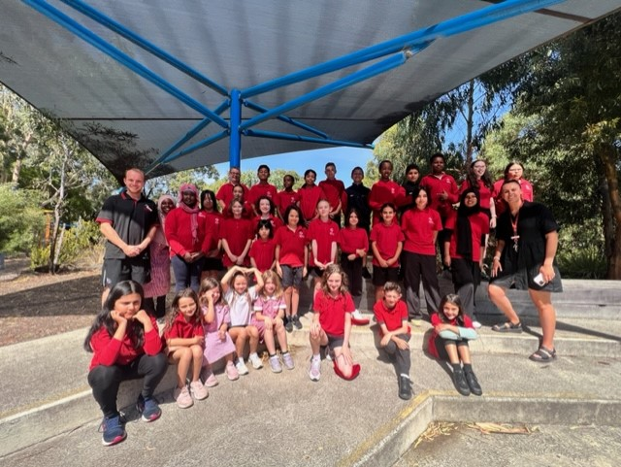

**Important Dates**

**Professional Practice Day**

For Term 1, 2023, the Department of Education and Training has provided schools with the option to hold each teacher’s allocated **Professional Practice Day** on the same day for all staff. This is to enable the most effective and efficient use of this day.

As a result, we have scheduled our Professional Practice Day for **Monday 27th March 2023**. Students are NOT required to attend school on this day.

**Last Day of Term 1**

Term 1 finishes on **Thursday 6th April**. Students will be dismissed at 2:30pm.

**Term 2**

On **Monday, 24th April,** Broadmeadows Valley PS will be having a Curriculum Day. Students are NOT required to attend school on this day. On **Tuesday 25th April,** it is a Public Holiday, ANZAC Day. Students are NOT required to attend school on this day. Term 2 will commence on **Wednesday 26th April 2023.** (All students will return to school on this day)

**NAPLAN**

Classes across Years 3 and 5 have already started preparing for their NAPLAN testing. This year the national testing period has been bought forward from May to March. As such, our teachers have been working with their students to familiarise them with the process and to assist with reducing their levels of anxiety or distress that they may be feeling with these formal assessments.

With the NAPLAN test all being delivered online, an important element is developing each students typing/keyboard skills. As we get closer to the date, more information will be provided to those families with children in these year levels.

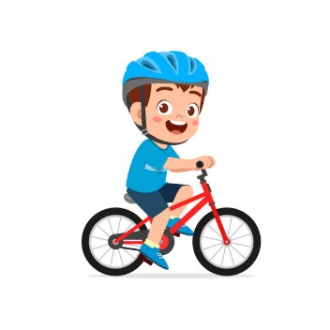**Scooters and Bikes**

Many students at our school ride a bike or scooter to and from school and it’s important that we keep all our students safe when students are riding a bike or a scooter.

Therefore, please remember that **ALL** students who ride a bike or scooter to and from school **MUST** wear a helmet.

**Attendance-Every Day Counts!**

Going to school every day is the single most important part of your child’s education. Students learn new things at school every day – missing school puts them behind.

***SCHOOL IS BETTER WHEN YOUR CHILD IS THERE- Why it’s important?***

We all want our students to get a great education, and the building blocks for a great education begin with students coming to school each and every day. If students miss school regularly, they miss out on learning the fundamental skills that will set them up for success in the later years of school.

There is no safe number of days for missing school – each day a student misses puts them behind, and can affect their educational outcomes.

Each missed day is associated with progressively lower achievement in numeracy, writing and reading.

Attendance patterns are established early – a child regularly missing days in kindergarten or in the early years of school will often continue to miss classes in the later years, and receive lower test scores than their classmates.

It’s vital that students go to school every day – even in the early years of primary school.

***The main reasons for absence are:***

Sickness – There are always times when students need to miss school, such as when they’re ill. It’s vital that they’re only away on the days they are genuinely sick. Developing good sleep patterns, eating well and exercising regularly can make a big difference.

Family holidays - It's vital that holidays are planned during school holidays where possible, and not during the term. If you are planning to go on holiday during term time, make sure you discuss your holiday plans with the Principal.

**BEING AWAY FROM SCHOOL FOR ONE DAY A FORTNIGHT EQUALS MISSING 1.5 YEARS OVER 13 YEARS OF SCHOOL**

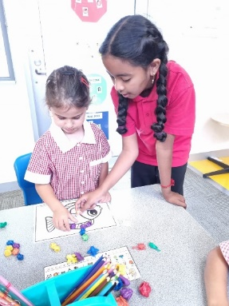

**Foundation Buddies**

Foundation students began working with their Year 4 buddies from LN3 this week.

It’s a wonderful opportunity for the Year 4 students to be involved in the ‘Buddy’ program and they are enjoying the opportunity to take part in the program.

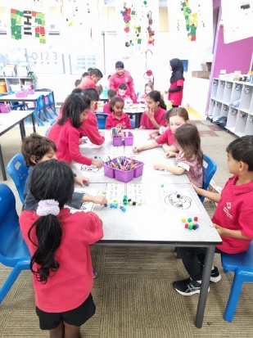Already the buddies have been working with the Foundation students during Maths sessions and the Foundation students love working with their buddy!

Throughout the year, Foundation students will be spending a lot of time with their buddies to do fun activities together!

**Inter-School Sport**

BVPS Year 5/6 interschool sports has started off with some great results. We played against Bethal Primary School in the first round winning most of our matches.

Last week in round two we played Campbellfield Heights Primary School, and our boys' basketball team wearing the BVPS red jerseys had a victorious win scoring 18 to 12 Round three is a BYE (opposition school has withdrawn from the round) for us so all team sports will be busy practising for the next round.

BVPS is looking forward to the upcoming matches with the schools in our district and we wish all players the very best of luck.

Stay tuned for more interschool sports updates and results.

**STOPIT Service**

STOPIT is a new Victoria Police text notification service enabling commuters, including school students, to report any form of inappropriate behaviour that makes them feel uncomfortable, frightened or threatened on the public transport network.

The STOPIT service enables commuters to use their mobile phone to promptly, easily and discreetly report inappropriate behaviours.

To use the service, commuters simply text ‘STOPIT’ to 0499 455 455. This triggers an automated response that includes a link to where the commuter can provide more details about what’s just happened.

When people report these types of inappropriate behaviours, police can investigate and identify offenders to improve safety on public transport for everyone.

Parents and carers are encouraged to consider discussing the new service with students who travel on public transport. Students who use mobile phones outside of school hours are encouraged to save the STOPIT number in their mobile phone.

Please note, STOPIT is for reporting non-urgent incidents on public transport. Always phone 000 in an emergency.

**Foundation 2024**

Already, we have had enquiries about enrolments for **2024.** If you know someone who lives in Broadmeadows and is interested in our school, please ask them to telephone the school office to book a place on one of our tours.

If you already have children at our school and have a Foundation student for next year, please make sure you come and collect the enrolment pack so we can add you to our list!!

We will be operating Foundation 2024 School Tours on the following dates/times:

**Wednesday 8th March 2023 at 1:00pm**

**Wednesday 15th March 2023 at 3:30pm**

**School Council Elections**

At the closing of the period for School Council nominations, we had one parent nomination and two community nominations.

Our parent representatives on School Council are: Amanda Saunders, Tamara Guy, Koren Staff, Ahmed Nadeem. Our two community representatives are: Marcelle Jackson and Michelle Gruyer. Staff members on School Council are: Belinda Karlsson, Jamielee Black and Jenny Petrone.

The first meeting of the new School Council will be on **Tuesday 28th March 2023 at 5pm.**

**Learners of the Week – Week 4, 5 & 6**

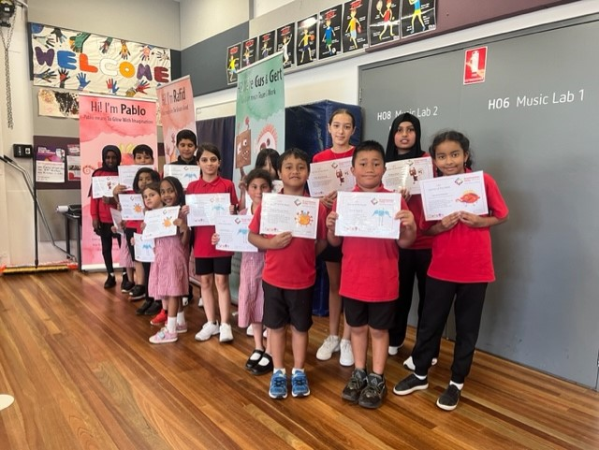

***Have a great weekend!***

**Belinda Karlsson**

**Principal**

**School Diary Dates**

**Term Dates 2023**

**Term 1**

**Teeth on Wheels (Dentist)- Tuesday 7th March**

**Foundation 2024 School Tour - Wednesday 8th March at 1:00pm**

**Public Holiday- Monday 13th March 2022 (no students at school this day)**

**Foundation 2024 School Tour- Wednesday 15th March at 3:30pm**

**NAPLAN -Year 3 and Year 5 - 15th March – 28th of March**

**Harmony Day Tuesday 21st March**

**Science Incursion Friday 24th March**

**Professional Practice Day - Monday 27th March 2023 (no students at school this day)**

**Inter-School Sport- Term 1**

**Friday 10th March -BVPS Vs Dallas Brooks CPS (Away Game)**

**Friday 17th March- BVPS Vs Coolaroo South PS (Home Game)**

**Friday 24th March- BVPS Vs Meadows PS (Away Game)**

**Friday 31st March- BVPS Vs IIim College (Away Game)**

**Last Day of Term 1- Thursday 6th April 2023 (Students dismissed at 2:30pm)**

**Term 2**

**Curriculum Day- Monday 24th April (no students at school this day)**

**Public Holiday (ANZAC Day)- Tuesday 25th April (no students at school this day)**

**Students commence school- Wednesday 26th April**

**School Photos-Wednesday 3rd May**

MATHS CHALLENGE

Welcome to the Week 6 Maths Challenge. Let your teacher or Miss Sharon know if you find the solution this week. Good luck and just do your best.



**Promoting a Positive Climate at BVPS**

|  |
| --- |
| **Positive Behaviour**  It has been great to see so many students at Breakfast club each day. We invite everyone to come along and enjoy a delicious breakfast.    Classrooms have been working on learning about and celebrating our learning value monsters. |

|  |
| --- |
| **Social and Emotional Learning**  Students are currently learning about personal strengths such as **reliable, flexible, kind, hard working, creative, punctual, and positive. They are learning how they can use these strengths inside and outside of the classroom.**  A picture containing timeline  Description automatically generated  The mental health continuum **describes a range of states, with mental health and mental illness at the two extreme ends**. Depending on the internal and external faculties of a person at any time, they can lie at one point of the continuum and shift position as their situation improves or deteriorates. The Mental health continuum is good language to use with our children. We all sit somewhere on the mental health continuum however our emotions will change and there are no good or bad emotions. |

|  |
| --- |
| **Promoting Wellbeing and Health**  Smiling mind is a great meditation app to use with the kids before bed or after a busy day.  <https://www.smilingmind.com.au/>  You can also download it onto your computer or phone.  Icon  Description automatically generated with low confidence |

|  |
| --- |
| **Upcoming Events**   * International Women’s Day on Wed March 8th * Harmony Week Mon 20th - Sun 26th March * Wellbeing Team Pizza and Plane afternoon March 30th, |

